 | Pimpri Chinchwad Education Trust’s  Pimpri Chinchwad College of Engineering  (PCCoE)  (An Autonomous Institute)  Affiliated to Savitribai Phule Pune University(SPPU) ISO 21001:2018 Certified by TUV | 
Course: DevOps Laboratory | Code: BIT26VS01
Name: Amar Vaijinath Chavan | PRN: 124B2F001
Assignment 14: Discover Infrastructure as Code using Terraform and write a Terraform script to create a virtual machine (EC2).

Aim: To explore the principles of Infrastructure as Code (IaC) and automate the provisioning of an
AWS EC2 instance using Terraform.

Objectives:
- To understand the core concepts of Infrastructure as Code (IaC) and the Terraform lifecycle.
- To develop a Terraform configuration for provisioning cloud infrastructure.
- To execute the workflow of init, plan, apply, and destroy to manage cloud resources.

Theory
- Infrastructure as Code (IaC)
Infrastructure as Code is a key DevOps practice that involves managing and provisioning computing infrastructure through machine-readable definition files rather than physical hardware configuration or interactive configuration tools. IaC allows for consistency, repeatability, and version control of infrastructure, significantly reducing manual errors and deployment time.

- Terraform Overview
Terraform is an open-source IaC tool created by HashiCorp. It allows users to define both cloud and on-premises resources in human-readable configuration files that can be versioned, shared, and reused. Terraform uses HashiCorp Configuration Language (HCL) to describe the desired "End State" of the infrastructure.

- Terraform Architecture and Lifecycle
Terraform operates on a plugin-based architecture, utilizing Providers (like AWS, Azure, or GCP) to interact with remote APIs. The standard lifecycle consists of:
- terraform init: Initializes the working directory and downloads necessary provider plugins.
- terraform plan: Creates an execution plan, showing what actions Terraform will take to reach the desired state.
- terraform apply: Executes the proposed plan to create or modify infrastructure.
- terraform destroy: Safely removes all managed infrastructure defined in the configuration.
- State Management
Terraform maintains a State File (terraform.tfstate) that acts as a source of truth, mapping the configuration to the real-world resources. This file allows Terraform to determine which changes are needed when the configuration is updated.

Practical Procedure / Steps
Step 1: Configure AWS CLI & Programmatic Access Before executing Terraform, the local
environment must be authenticated with AWS.
- Create IAM User: A new user named Terraform-User was created in the AWS Console.
- Attach Permissions: The AdministratorAccess policy was attached directly to ensure the user has rights to manage EC2 and Security Groups.
- Generate Access Keys: An Access Key and Secret Access Key were generated for Command Line Interface (CLI) use.
- AWS Configure: On the local Ubuntu machine, the command aws configure was used to input the Access Key ID, Secret Access Key, and set the default region to us-east-1.

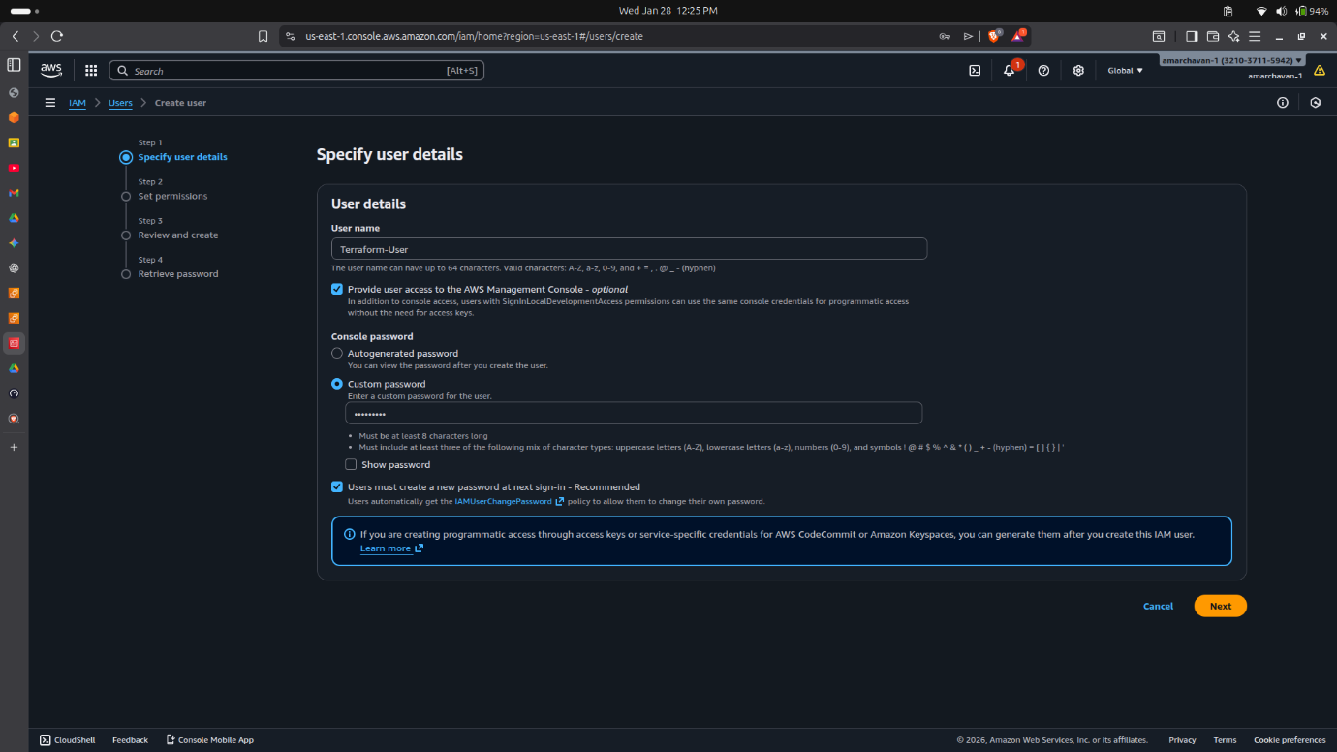
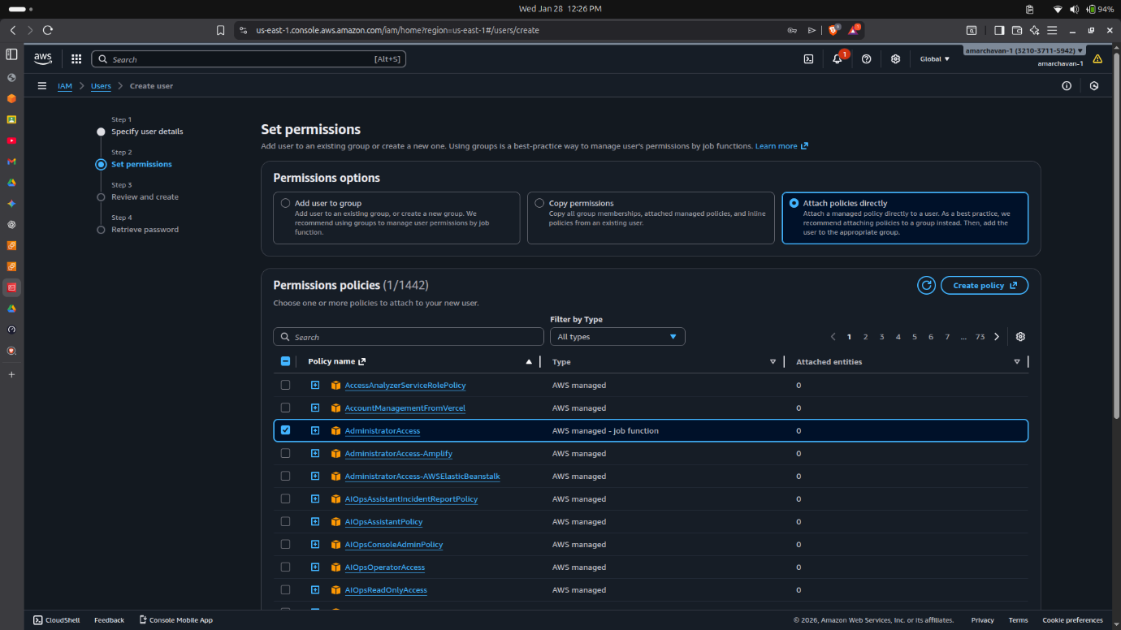
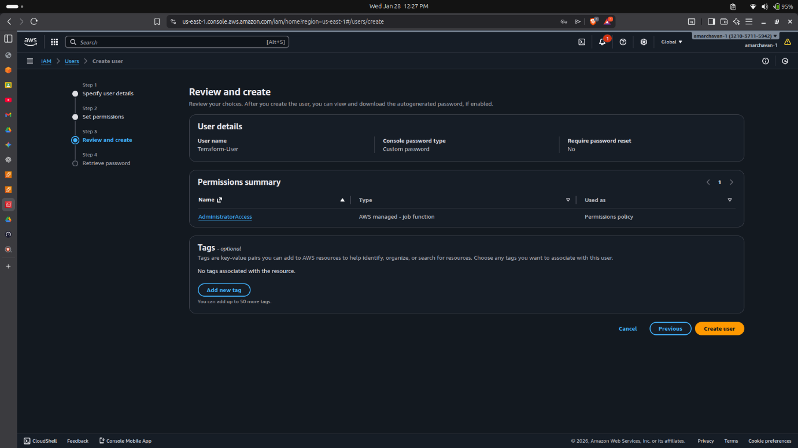
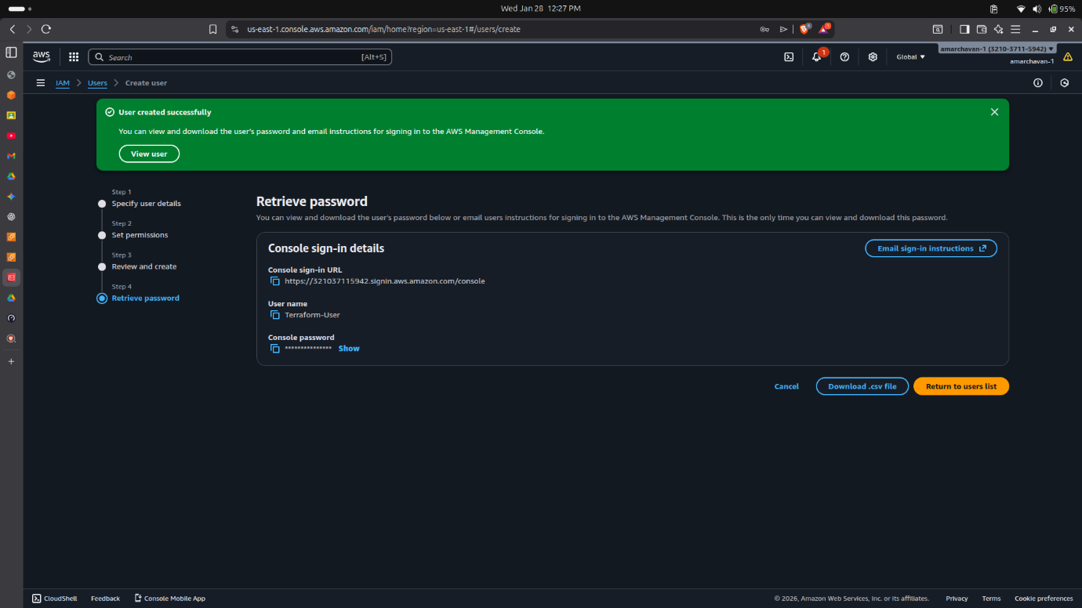
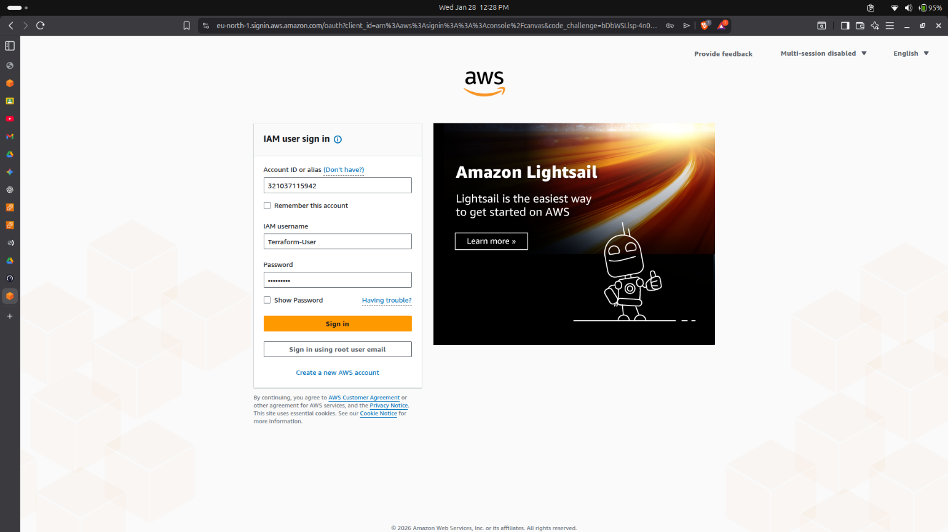

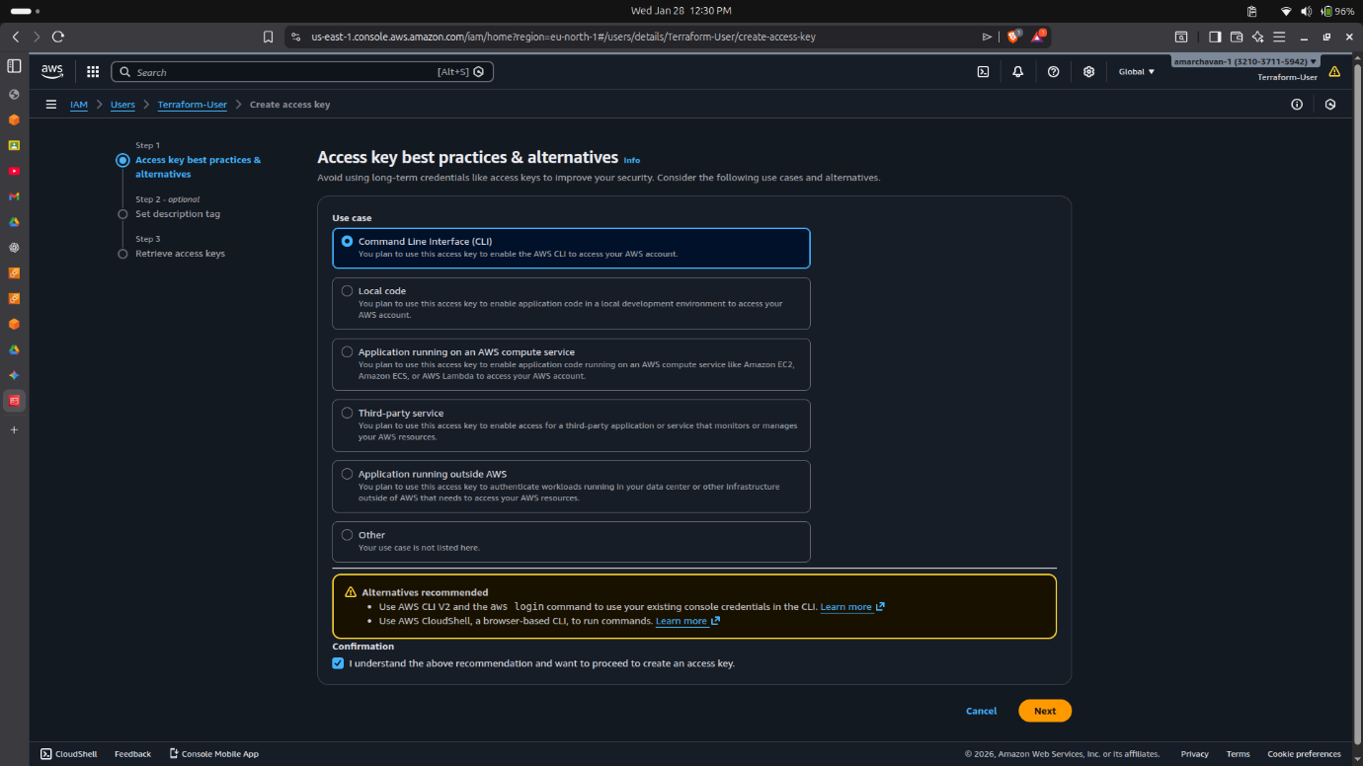
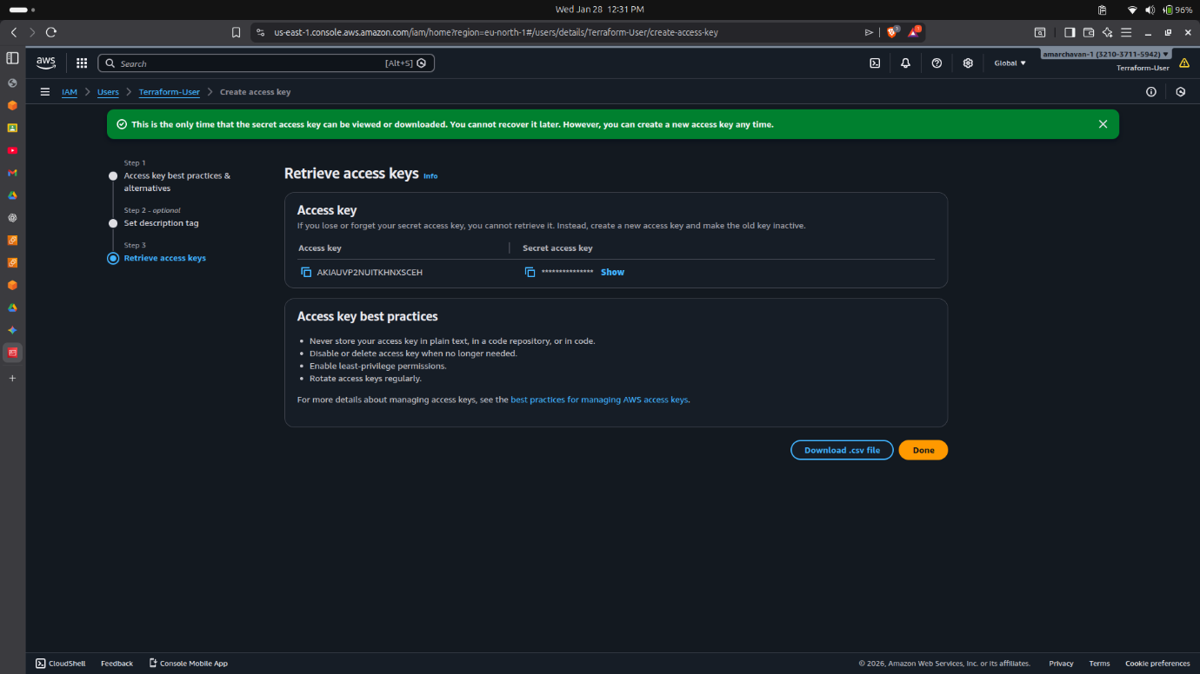
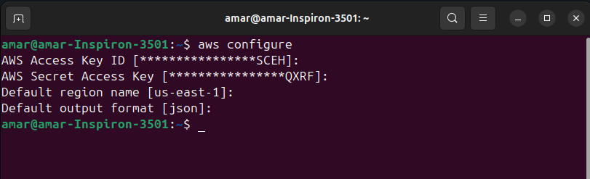

Step 2: Terraform Initialization
- Navigate to the project directory terraform-assignment-14.
- Execute terraform init to initialize the backend and download the HashiCorp AWS provider plugin (version v6.29.0).
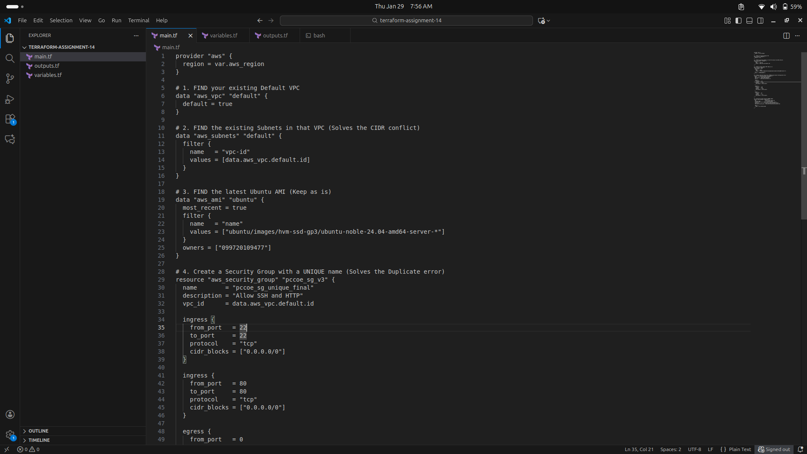

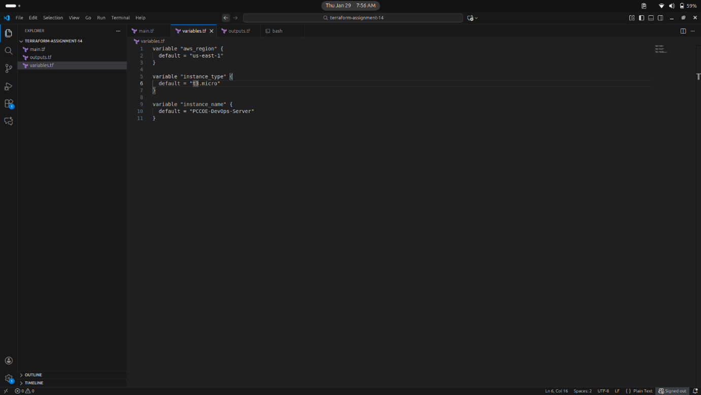
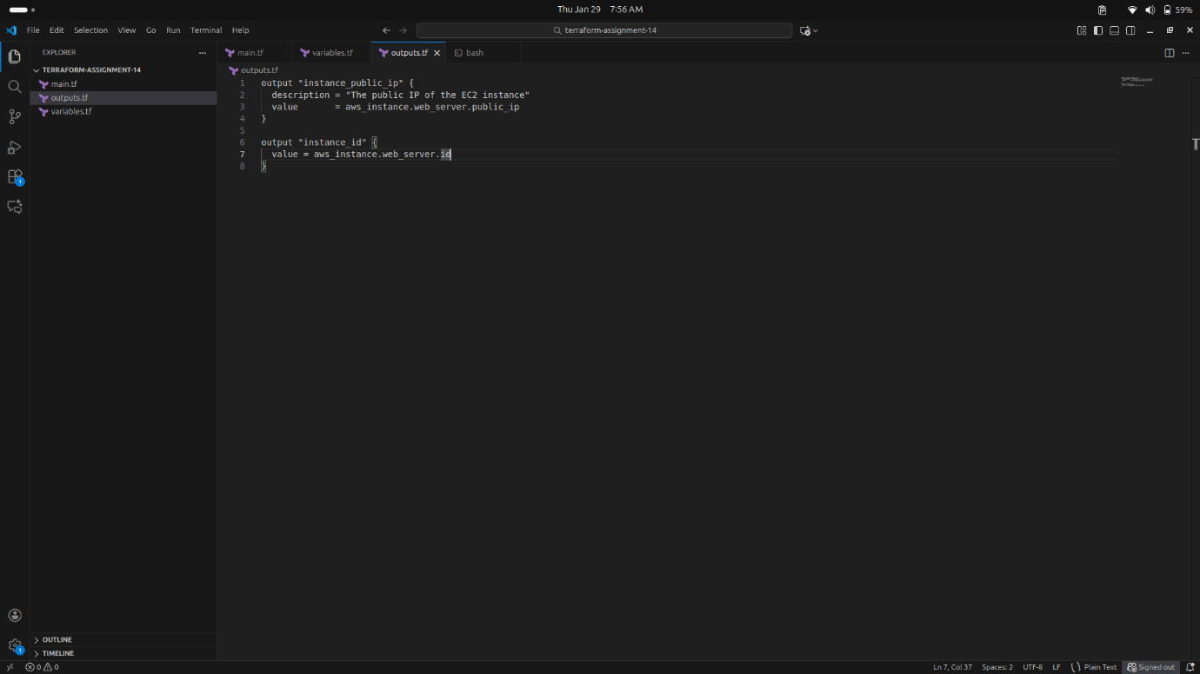

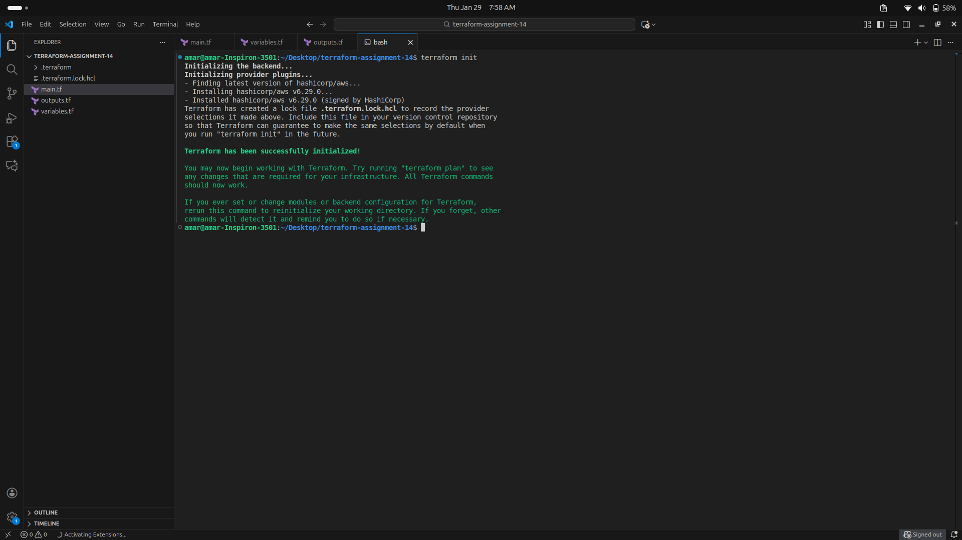

Step 3: Planning the Infrastructure
- Run terraform plan to generate an execution plan.
- The plan confirmed that 2 resources (an AWS Instance and a Security Group) would be added.
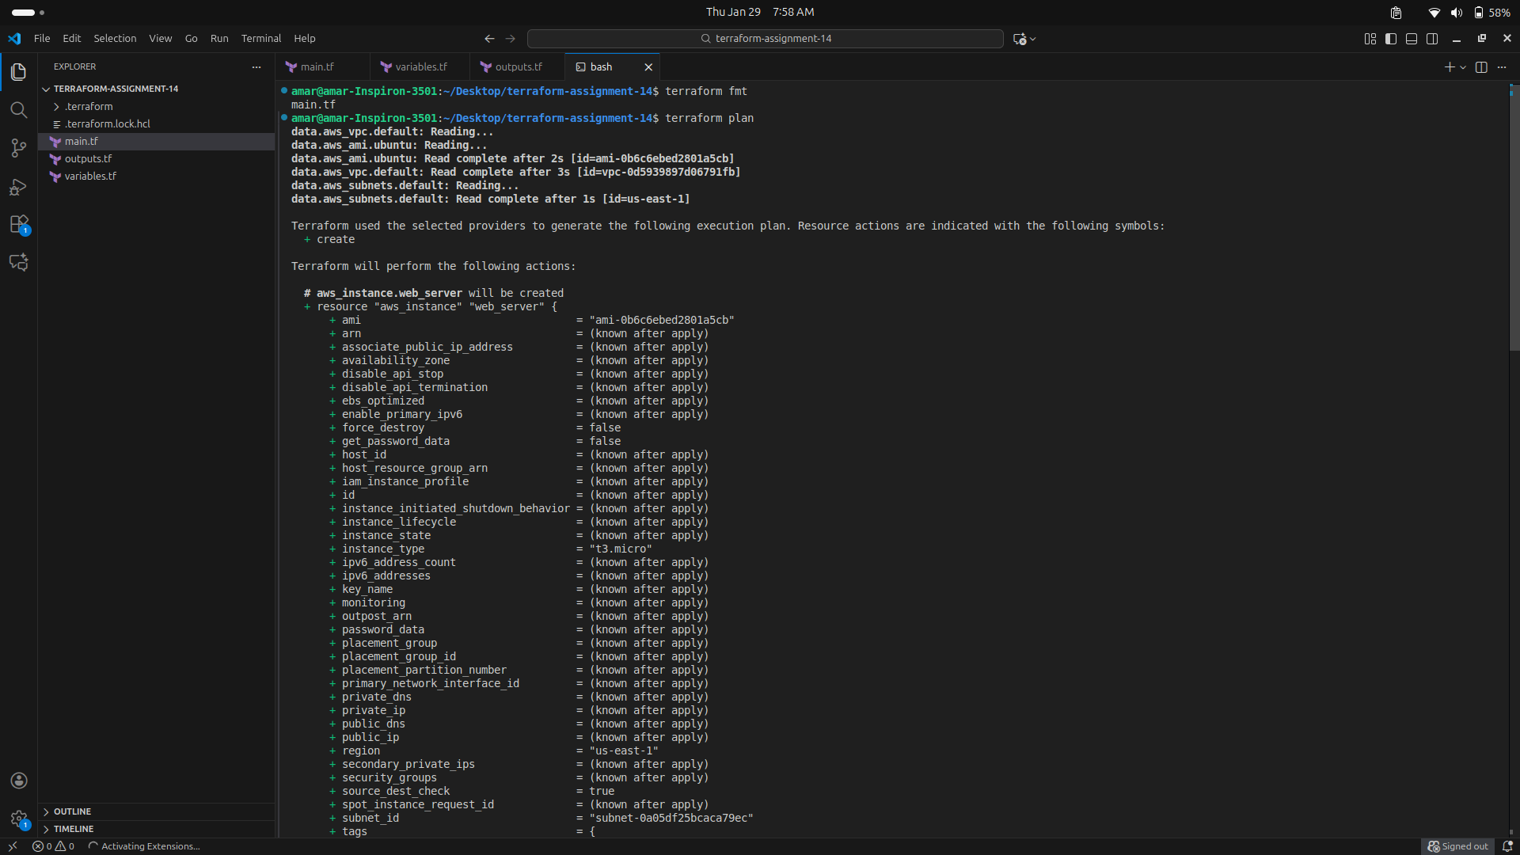
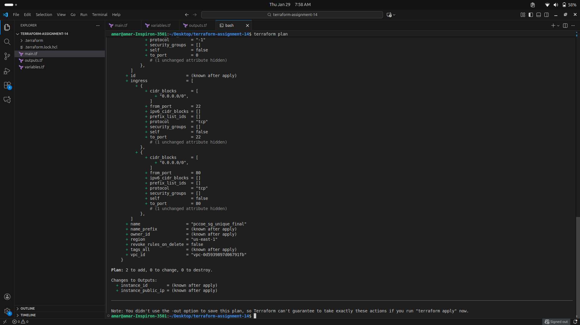

Step 4: Applying and Provisioning
- Execute terraform apply and type yes to confirm.
- Terraform provisioned the aws_security_group.pccoe_sg_v3 followed by the aws_instance.web_server named PCCOE-DevOps-Server.
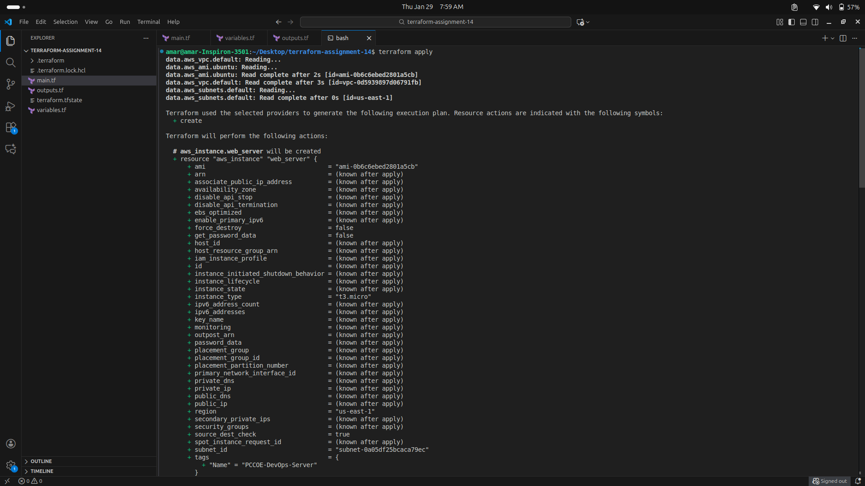
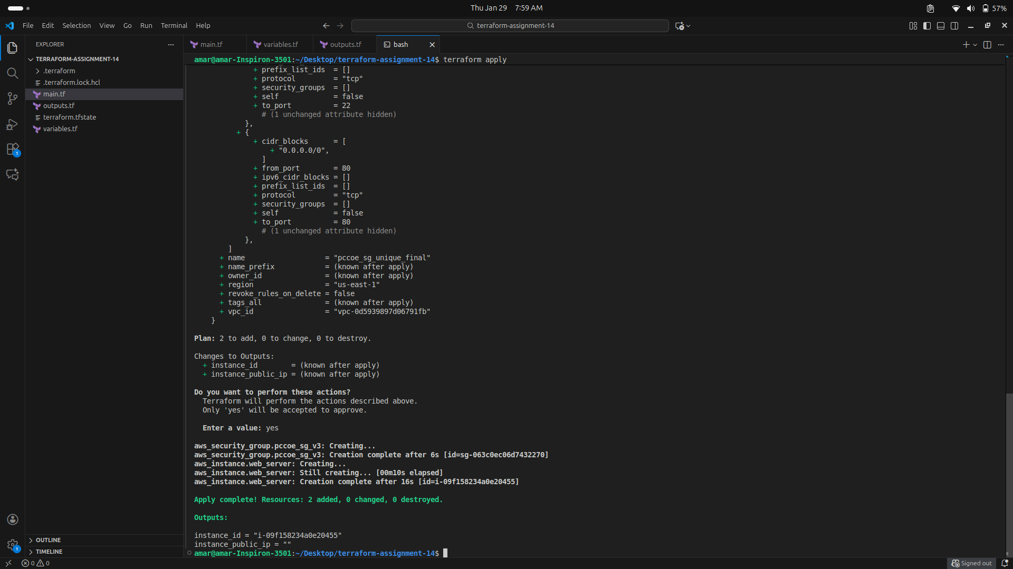

Step 5: Verification in AWS Console
- The EC2 Dashboard confirmed the instance i-09f158234a0e20455 was in a "Running" state with 3/3 status checks passed.

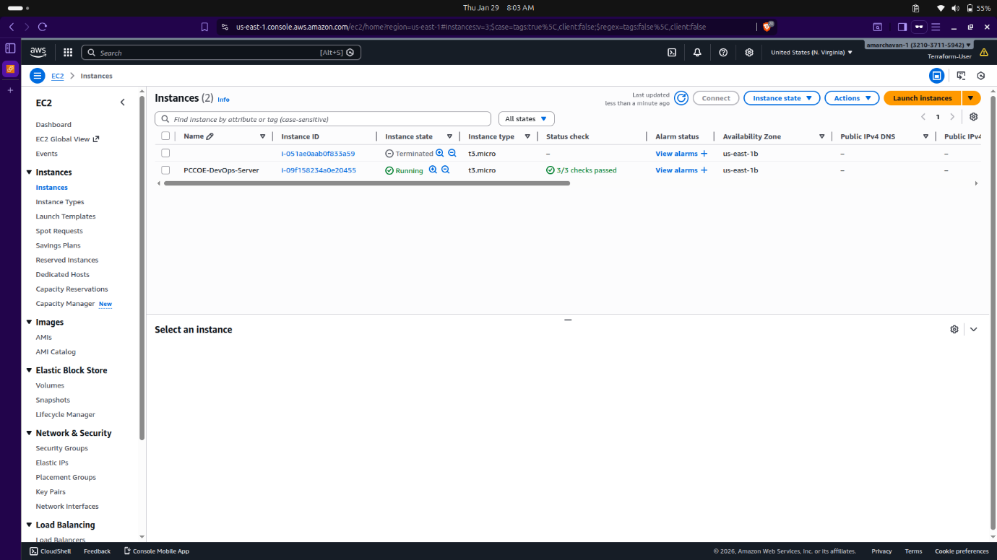
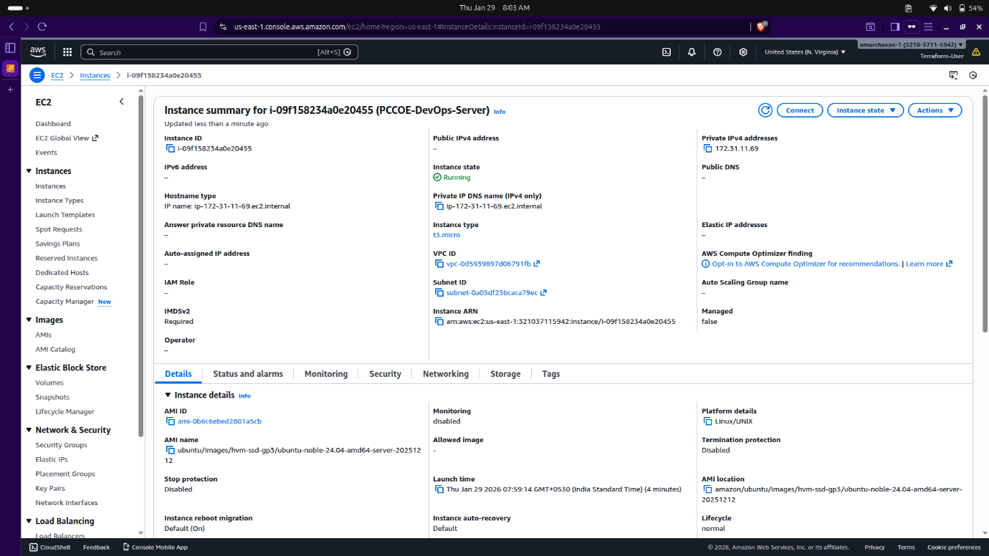

Step 6: Resource Destruction
- To clean up the cloud environment, run terraform destroy.
- This safely terminated the instance and deleted the security group from the AWS region.
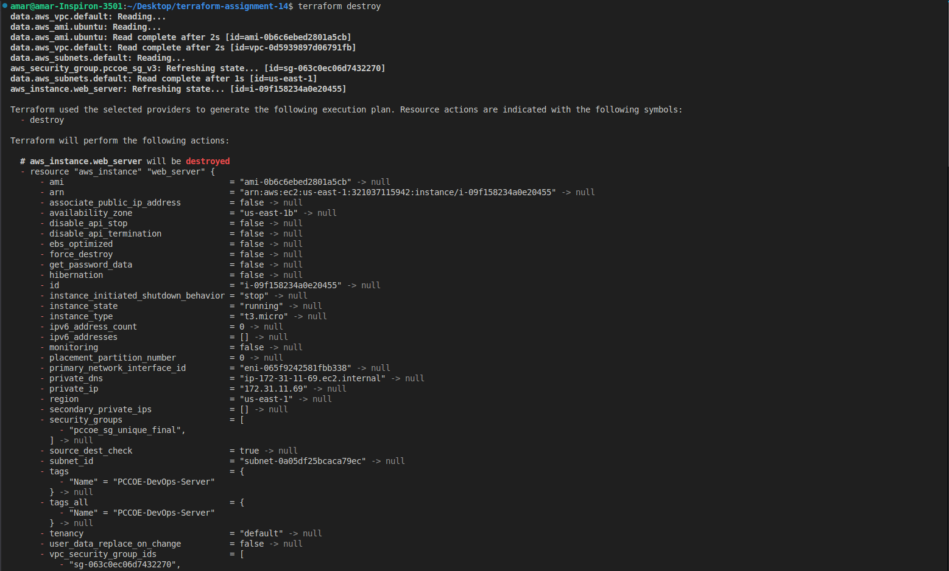
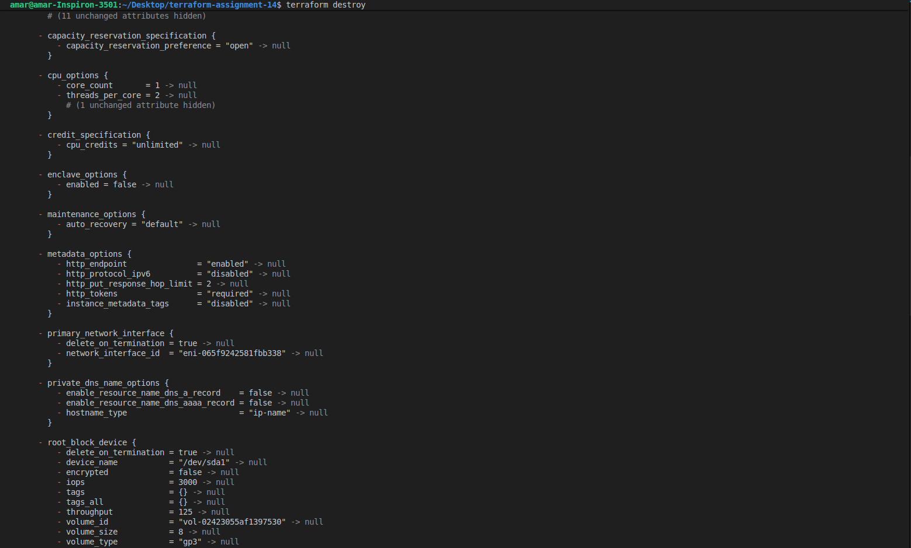

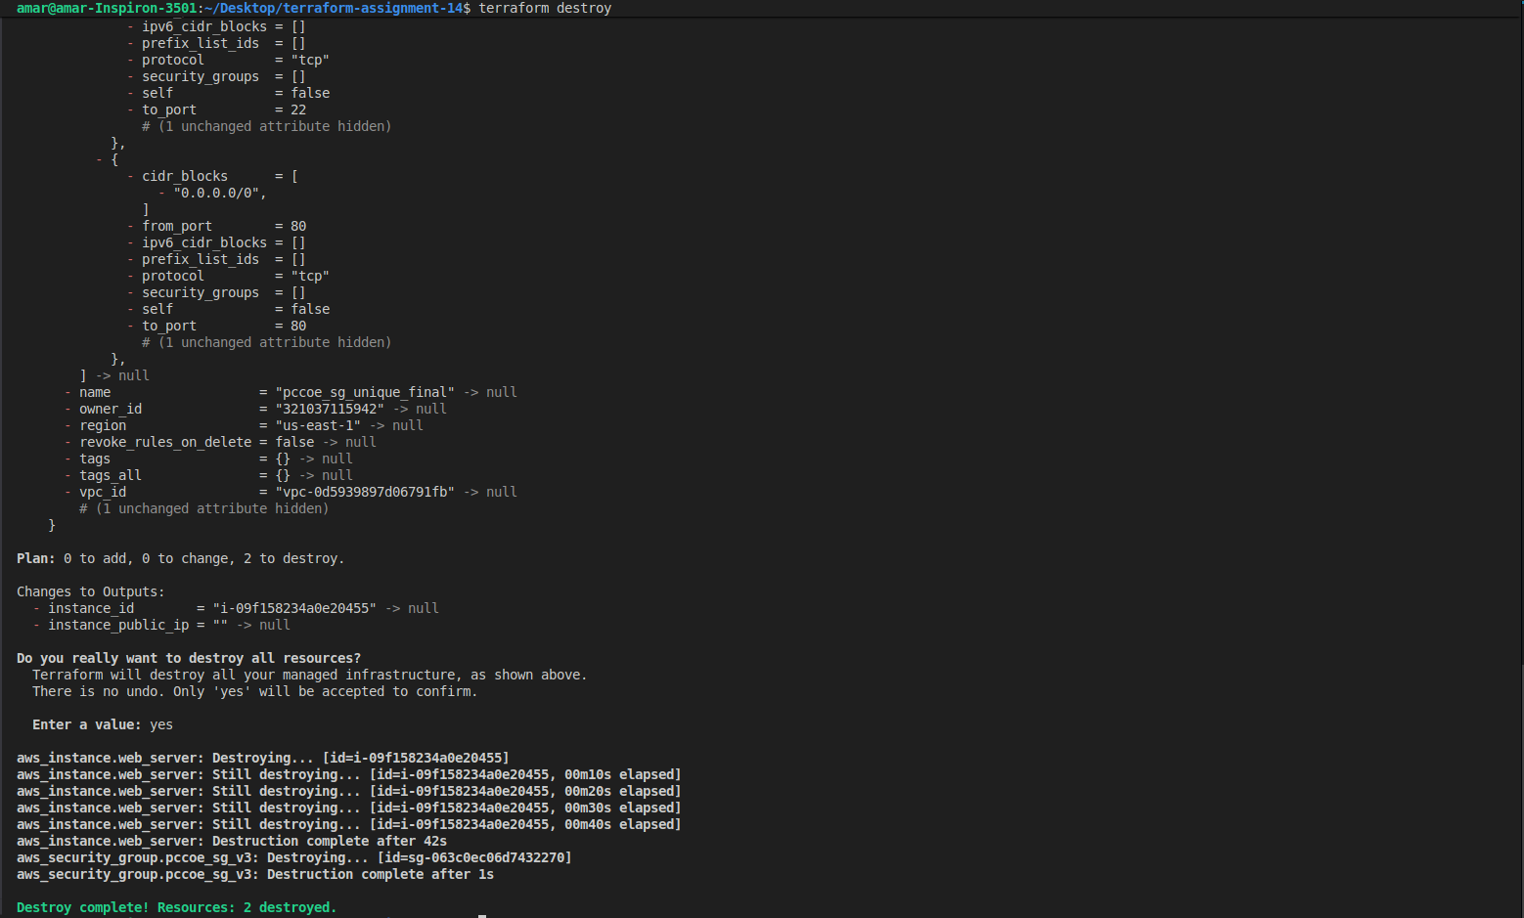

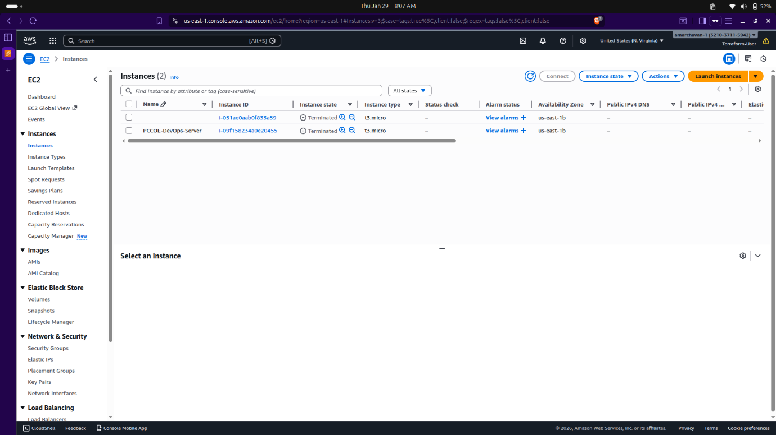

Conclusion
The successful execution of Assignment 14 effectively demonstrates the core principles of Infrastructure as Code (IaC) by automating cloud resource management. By transitioning from manual console-based provisioning to programmatic configuration via the AWS CLI, I established a secure and authenticated environment necessary for automated orchestration. The implementation of the Terraform lifecycle—encompassing init, plan, apply, and destroy—provided a structured and predictable workflow for managing the PCCOE-DevOps-Server instance.
A key takeaway was the importance of State Management, where the terraform.tfstate file ensured that the local configuration remained synchronized with the real-world cloud resources. Furthermore, the ability to safely terminate and delete the infrastructure using the destroy command highlighted the efficiency and cost-control benefits of using Terraform in a DevOps pipeline. Ultimately, this assignment validates that using HCL-based scripts ensures consistency, repeatability, and significantly reduces the manual overhead typically associated with managing enterprise-scale cloud infrastructure.

